# BUSINESS INTELLIGENCE

BI is the process for transforming raw or business data to useful information for business analysis.

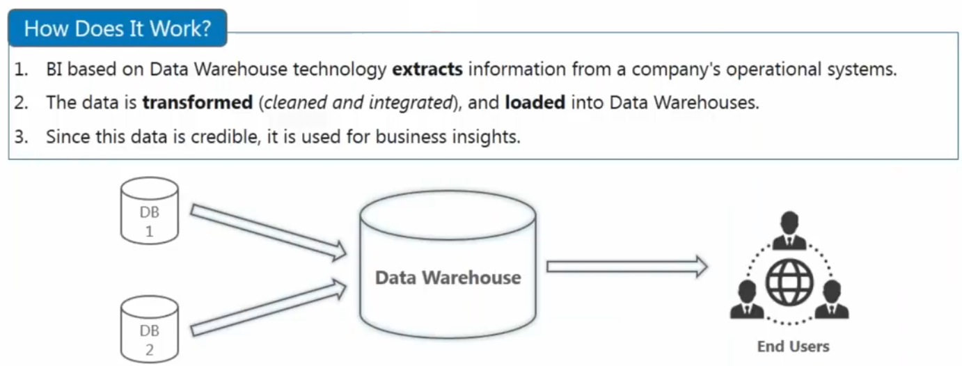

# DATA WAREHOUSE

A data warehouse (DW or DWH), also known as an enterprise data warehouse (EDW), is a system used for reporting and data analysis, and is considered a core component of business intelligence.

DWs are central repositories of integrated data from one or more different sources. They store current and historical data in one single place that are used for creating analytical reports.

* It’s a central location where consolidated data from multiple locations (various databases or files) are stored.
* DWH is maintained separately from an organizations operational database.
* End users access it whenever any information is needed.
* DWH is not loaded every time new data is added to database.

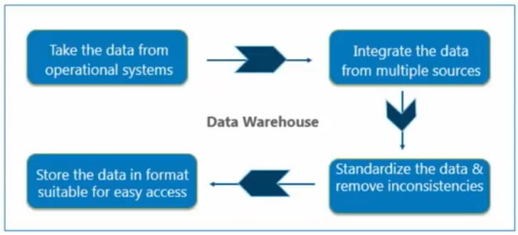

Below are some of the advantages of DWH:

# WHY DATA WAREHOUSE

